Customer Churn Prediction in Service-Oriented Businesses Using Machine Learning Techniques

Abstract
Customer churn is a critical challenge faced by service-oriented businesses such as telecommunications, banking, subscription-based platforms, and SaaS providers. Retaining existing customers is significantly more cost-effective than acquiring new ones, making churn prediction an essential business intelligence task. This project proposes a machine learning–based framework to predict customer churn using supervised learning techniques. The study benchmarks and compares the performance of multiple machine learning models—Random Forest (RF), XGBoost, and Support Vector Machine (SVM)—to identify the most effective algorithm for churn prediction. The system utilizes customer attributes such as tenure, monthly charges, and contract type as independent variables to predict churn status as the dependent variable. A web-based application developed using Streamlit enables interactive dataset analysis, model evaluation, and real-time churn prediction. Model performance is evaluated using accuracy, confusion matrix, and ROC-AUC score, with a target accuracy exceeding 85%.

Introduction
In today’s highly competitive service-driven economy, customer retention has become a key determinant of organizational profitability and sustainability. Customer churn refers to the phenomenon where customers discontinue their relationship with a service provider. High churn rates directly impact revenue, brand reputation, and long-term growth.
Traditional churn analysis methods rely on descriptive statistics and manual rule-based systems, which often fail to capture complex behavioral patterns. With the growth of big data and machine learning, predictive analytics has emerged as a powerful approach for identifying customers at risk of churn before they disengage.
Machine learning techniques can analyze large volumes of customer data, uncover hidden patterns, and generate accurate churn predictions. By proactively identifying high-risk customers, businesses can design targeted retention strategies such as personalized offers, service improvements, and customer engagement initiatives.
This project focuses on implementing and benchmarking supervised machine learning algorithms for churn prediction and deploying the best-performing model in a user-friendly web application using Streamlit.

Problem Statement
Service-oriented businesses face difficulty in accurately identifying customers who are likely to churn due to the following challenges:
- Large and complex customer datasets
- Non-linear relationships between customer attributes
- Inadequate predictive accuracy from traditional analytical methods
- Lack of real-time, interpretable decision-support systems
There is a need for an intelligent, data-driven churn prediction system that delivers high accuracy and actionable insights.

Aim
To design and implement a machine learning–based customer churn prediction system and deploy it as a web-based application for practical business use.

Objectives
- To benchmark and select the most effective machine learning algorithm for churn prediction in service sectors
- To compare supervised learning models such as Random Forest, XGBoost, and SVM
- To determine which model provides the highest predictive accuracy
- To analyze the influence of independent variables (Tenure, Monthly Charges, Contract Type) on churn status
- To develop an interactive web-based churn prediction application using Streamlit
Independent Variables (IV):
- Tenure
- Monthly Charges
- Contract Type
Dependent Variable (DV):
- Churn Status

Motivation
Customer acquisition costs are significantly higher than retention costs. Even a small reduction in churn can lead to substantial revenue gains. Accurate churn prediction enables businesses to:
- Retain valuable customers
- Improve customer satisfaction
- Reduce operational losses
- Enhance data-driven decision-making
The motivation behind this project is to leverage machine learning techniques to provide an automated, scalable, and interpretable churn prediction solution.

Research Methodology
The research methodology adopted in this project is comparative analysis of supervised machine learning models. The workflow includes:
- Data collection from Kaggle
- Data preprocessing and feature encoding
- Exploratory data analysis (EDA)
- Model training and hyperparameter tuning
- Performance evaluation using standard metrics
- Selection of the best-performing model
- Web application deployment using Streamlit

Scope of the Project
- Applicable to telecom, banking, insurance, SaaS, and subscription-based businesses
- Supports structured customer datasets
- Provides model comparison and visualization
- Can be extended to real-time business data
- Can integrate customer segmentation and recommendation systems

Dataset Description
The dataset used for this project is sourced from Kaggle:
Dataset Link:
https://www.kaggle.com/datasets/deaneshtakkallapati/customer-churn-prediction/data
The dataset contains customer demographic information, service usage details, billing information, and churn labels.

System Architecture

Existing Methods and Drawbacks

Existing Methods
- Rule-based churn analysis
- Manual customer segmentation
- Statistical regression models
- Basic decision trees

Drawbacks
- Poor handling of non-linear relationships
- Low predictive accuracy
- High false positives
- Lack of scalability
- No real-time prediction capability

Gaps Identified
- Insufficient benchmarking of multiple ML algorithms
- Limited use of ensemble models for churn prediction
- Absence of interactive visualization tools
- Lack of deployable churn prediction systems

Proposed System
The proposed system implements and compares Random Forest, XGBoost, and SVM models to predict customer churn. The best-performing model is integrated into a Streamlit-based web application that allows users to:
- Upload datasets
- Visualize churn trends
- Compare model performance
- Predict churn for individual customers

Detailed Methodology
- Data Preprocessing
  - Handling missing values
  - Label encoding categorical variables
  - Feature scaling
- Exploratory Data Analysis
  - Churn distribution analysis
  - Feature correlation analysis
  - Visualization of tenure and billing patterns
- Model Training
  - Random Forest Classifier
  - XGBoost Classifier
  - Support Vector Machine
- Model Evaluation
  - Confusion Matrix
  - Accuracy Score
  - ROC-AUC Curve
- Model Selection
  - Best model selected based on ROC-AUC and accuracy (>85%)
- Web Application Development
  - Streamlit-based UI
  - Model inference integration
  - Visualization dashboards

Workflow Diagram
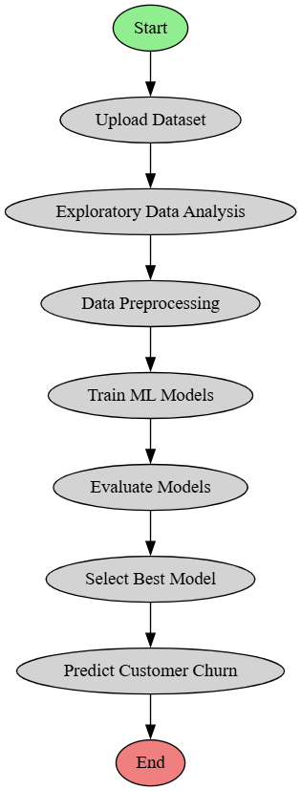

Hardware Requirements
- Processor: Intel i5 or higher
- RAM: Minimum 8 GB
- Storage: 10 GB free disk space
- Internet connectivity

Software Requirements
- Operating System: Windows / Linux
- Programming Language: Python 3.8+
- Libraries:
  - NumPy
  - Pandas
  - Scikit-learn
  - XGBoost
  - Matplotlib / Seaborn
  - Streamlit

Applications
- Telecom churn analysis
- Banking customer retention
- SaaS subscription analytics
- Insurance policy renewal prediction
- E-commerce customer loyalty management

Expected Output
- Accuracy greater than 85%
- Confusion Matrix for each model
- ROC-AUC score comparison
- Interactive Streamlit web application
- Real-time churn prediction results

Advantages
- High prediction accuracy
- Automated churn detection
- Scalable and reusable framework
- Business decision support
- User-friendly web interface

Work Breakdown Structure (WBS)
- Problem Identification
- Dataset Collection
- Data Preprocessing
- Exploratory Data Analysis
- Model Development
- Model Evaluation
- Web Application Development
- Testing and Validation
- Documentation and Reporting

Conclusion
This project successfully demonstrates the application of machine learning techniques for predicting customer churn in service-oriented businesses. By benchmarking Random Forest, XGBoost, and SVM models, the system identifies the most accurate predictive model based on standard evaluation metrics. The deployment of the model through a Streamlit-based web application enhances usability and practical applicability. The proposed solution enables businesses to proactively manage customer retention strategies, reduce churn rates, and improve long-term profitability.

